Implementation of Best First Search and A* Search

**Code for Best first Search:**

from queue import PriorityQueue

import matplotlib.pyplot as plt

import networkx as nx

*# for implementing BFS | returns path having lowest cost*

def best_first_search(source, target, n):

 visited = [0] * n

 visited[source] = True

pq = PriorityQueue()

pq.put((0, source))

 while pq.empty() == False:

 u = pq.get()[1]

print(u, end=" ") *# the path having lowest cost*

if u == target:

 break

 for v, c in graph[u]:

 if visited[v] == False:

 visited[v] = True

pq.put((c, v))

print()

*# for adding edges to graph*

def addedge(x, y, cost):

 graph[x].append((y, cost))

 graph[y].append((x, cost))

G = nx.Graph()

v = int(input("Enter the number of nodes: "))

graph = [[] for i in range(v)] *# undirected Graph*

e = int(input("Enter the number of edges: "))

print("Enter the edges along with their weights:")

for i in range(e):

 x, y, z = list(map(int, input().split()))

addedge(x, y, z)

G.add_edge(x, y, weight = z)

source = int(input("Enter the Source Node: "))

target = int(input("Enter the Target/Destination Node: "))

print("\nPath: ", end = "")

best_first_search(source, target, v)

**Output:**

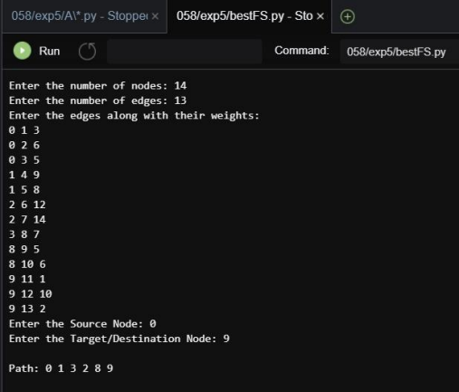

**Code for A* search:**

from collections import deque

class Graph:

 def __init__(self, adjacency_list):

self.adjacency_list = adjacency_list

 def get_neighbors(self, v):

 return self.adjacency_list[v]

 def h(self, n):

 H = {'A': 1,'B': 1,'C': 1,'D': 1}

 return H[n]

 def a_star_algorithm(self, start_node, stop_node): open_list = set([start_node])

closed_list = set([])

 g = {}

 g[start_node] = 0

 parents = {}

 parents[start_node] = start_node

 while len(open_list) > 0:

 n = None

 for v in open_list:

 if n == None or g[v] + self.h(v) < g[n] + self.h(n):  n = v;

 if n == None:

print('Path does not exist!')

 return None

 if n == stop_node:

reconst_path = []

 while parents[n] != n:

reconst_path.append(n)

 n = parents[n]

reconst_path.append(start_node)

reconst_path.reverse()

print('Path found: {}'.format(reconst_path))  return reconst_path

 for (m, weight) in self.get_neighbors(n):  if m not in open_list and m not in closed_list: open_list.add(m)

 parents[m] = n

 g[m] = g[n] + weight

 else:

 if g[m] > g[n] + weight:

 g[m] = g[n] + weight

 parents[m] = n

 if m in closed_list:

closed_list.remove(m)

open_list.add(m)

open_list.remove(n)

closed_list.add(n)

print('Path does not exist!')

 return None

adjacency_list = {

 'A': [('B', 1), ('C', 3), ('D', 7)],

 'B': [('D', 5)],

 'C': [('D', 12)]

}

graph1 = Graph(adjacency_list)

graph1.a_star_algorithm('A', 'D')

**Input Graph:**

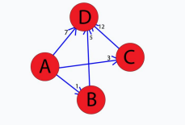

**Output:**

